ABM variables from survey

**PID2A_1**

Imagine a season in which there is not enough water for farming. Would you consider farming with the expectation of rainwater? (449 yes, 158 no)

**LAN1 Tenure**

_B Type of land

Paddy/lowland (1)

Highland (2)

_G How do you generally irrigate this land?

_U In the past five years, how many seasons have you cultivated this land?

_V Why did you not cultivate?

_W Of cultivated seasons, how many had lower harvest than expected because of low water/rain availability?

**LAN3 Agrowell**

_A Use an agrowell (1) or pond (2)

_D Who owns it?

_E How much did it cost?

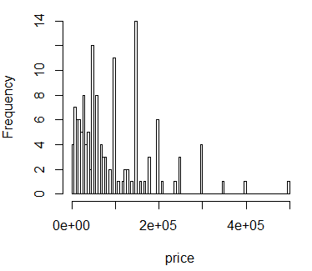

FAR1

_3G Total cost for the season

_5 paddy yield

_20 Normally cultivate OFC in paddy land?

_21 How many acres did you cultivate with OFC last season?

_23 Total cost of cultivating OFC in paddy land (per season)?

_24 Estimated earnings from OFC in paddy land by selling per season? (Rs)